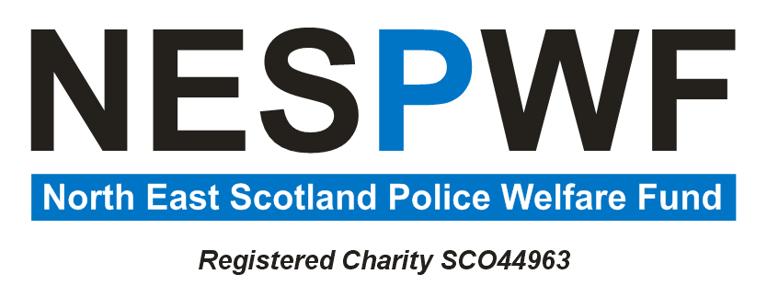
Appendix B

Application for Assistance Reference Number:

Particulars of Applicant
Name
Address
Post Code
Telephone No.
Email Address

Particulars of Spouse/ Partner/ Relative requiring assistance
(If different from Applicant)
Name
Address
Post Code

Assistance Requested | Grant/Loan (delete as necessary)
Amount Requested | £
Date of Request
Constitutionally Compliant? | Yes / No
Consider under Clause 4A / 4B?

Nature of Assistance requested (Please give full details of circumstances)
Nature of Assistance requested (continued – use separate sheet if required)

I declare that the information I have given above, to the best of my knowledge, is correct.

Signature of Applicant

Date

I declare that the information I have given above, to the best of my knowledge, is correct

Signature of Applicant’s spouse/ partner/ relative etc.

Date

APPLICATION FOR ASSISTANCE – ANALYSIS OF FINANCES
Monthly Household Income | £ | Monthly Household Expenditure | £
Wages  Pensions  Benefits |  | Housing -  Mortgage  Rent  Council Tax
Other Sources – |  | Utilities -  Gas  Electric  Oil
 |  | Telephone – Landline/Mobile
 |  | TV – Satellite/Licence
 |  | House Insurance – Building/Contents
 |  | Insurances
 |  | Living Costs – Food etc.
Car -
Fuel
Insurance
Excise
 |  | Travel costs
 |  | Clothing
 |  | Carer
Liabilities –
Loans
HP
 |  | Other –
TOTAL INCOME |  | TOTAL EXPENDITURE
Savings/Capital - Bank(s)/Building Societies/Investments/ Property
I declare that the information I have provided above is, to the best of my knowledge, correct.

Signature of Applicant/ Applicant’s spouse/ partner/ relative etc.

Date

DATA PROTECTION DECLARATION – see below

Data Protection declaration -

I understand that in making this application, I have provided accurate information which contains my personal data under the Data Protection Act 2018. As such, I consent to the North East Scotland Police Welfare Fund (the Fund) holding and processing this information on paper and/or electronic form, but only for the purposes of consideration of the application by the Trustees and its subsequent administration.
I understand this personal data will not be released to any 3rd party without my specific written consent, unless required by court tribunal order or by law.
I understand that the Fund will hold this data until the application is decided upon and for 6 years thereafter, primarily for auditing purposes.’
I understand my consent to this processing of my personal data can be withdrawn at any time by advising the Fund.

Signature of Applicant/ Applicant’s spouse/ partner/ relative etc.

Date

**************************FOR TRUSTEES USE ONLY**************************

Name of NESPWF Trustee noting request

I have assessed the applicant’s circumstances and confirm that there would/not appear to be a condition of need.

Signature

Date
NESPWF Trustees making decision/ Minute of Meeting dated

Decision – Approved/ Not approved/ Other

Date

Applicant Advised of Decision by

Date

